**Topics: Normal distribution, Functions of Random Variables**

1. The time required for servicing transmissions is normally distributed with *μ* = 45 minutes and *σ* = 8 minutes. The service manager plans to have work begin on the transmission of a customer’s car 10 minutes after the car is dropped off and the customer is told that the car will be ready within 1 hour from drop-off. What is the probability that the service manager cannot meet his commitment?
2. 0.3875
3. **0.2676**
4. 0.5
5. 0.6987

**ANS : Normal distribution with *μ* = 45 & *σ* = 8**

**Let us consider, X be the amount of time it takes to complete the repairing of car in one hour.**

**We have to calculate Pr(X > 50)**

**Pr(X > 50) = 1 – Pr(X ≤ 50)**

**Now,**

**Z = (X - *μ) / σ***

**= (X – 45) / 8**

**Pr(X ≤ 50) = Pr (Z ≤ (50-45)/8)**

**= Pr (Z ≤ 0.625)**

**Now by using normal distribution table we can say,**

**Pr (Z ≤ 0.625) = 0.7324**

**= 73.24%**

**The probability that the service manager cannot meet his commitment will be,**

**= 100 – 73.24**

**= 26.76 %**

**= 0.2676**

1. The current age (in years) of 400 clerical employees at an insurance claims processing center is normally distributed with mean *μ* = 38 and Standard deviation *σ* =6. For each statement below, please specify True/False. If false, briefly explain why.
2. More employees at the processing center are older than 44 than between 38 and 44.

**ANS : Given statement is False.**

* **If more employees are older than 44, it means *μ* is tending towards 44 but it was 38.**
* **If considering standard deviation, it is not possible as *μ*  is given 38 with**

***σ* =6.**

1. A training program for employees under the age of 30 at the center would be expected to attract about 36 employees.

**ANS : Given statement is True.**

**Z = (X - *μ) / σ***

**Pr(X ≤ 30) = Pr(Z ≤ (30-38)/6)**

**= Pr(Z ≤** **-1.33)**

**= 0.09176 ………………..(From Z table)**

**Required or expected count = 0.09176 * 400**

**= 36.704**

**≈ 37**

1. If *X1* ~ *N*(μ, σ2) and *X*2 ~ *N*(μ, σ2) are *iid* normal random variables, then what is the difference between 2 *X*1 and *X*1 + *X*2? Discuss both their distributions and parameters.

**ANS :**

* **2X1 will just larger scale version of X1, so as X1 normally distributed 2X1 also normally distributed.**
* **X1 & X2 both variables are independent normal random variables and hence**

**X1 + X2 are exactly normal with associate parameters.**

1. Let X ~ N(100, 202). Find two values, *a* and *b*, symmetric about the mean, such that the probability of the random variable taking a value between them is 0.99.
2. 90.5, 105.9
3. 80.2, 119.8
4. 22, 78
5. **48.5, 151.5**
6. 90.1, 109.9

**ANS : We have to find the value of a & b which are symmetric about the mean**

**The probability of getting value between a & b,**

**= 1 – 0.99**

**= 0.01**

**The probability towards left from a,**

**= ( - ) 0.01/2**

**= - 0.005**

**And probability towards right from b,**

**= ( + ) 0.001/2**

**= 0.005**

**Now we got the probabilities if a & b, we have to calculate random variable at a & b ,**

**We know,**

**Z = (X - *μ) / σ ……………………….* ❶**

**We are interested to calculate X,**

**( Z * *σ* ) + *μ* = X ……………………. ( From Eq. ❶)**

**For probability 0.005 the Z value is -2.575829 ………. ( Taken from Z table )**

**X = ( Z * *σ* ) + *μ***

**For (-0.005)**

**X = - ( - 2.575829 ) *20 + 100**

**= 151.51658**

1. Consider a company that has two different divisions. The annual profits from the two divisions are independent and have distributions Profit1 ~ N(5, 32) and Profit2 ~ N(7, 42) respectively. Both the profits are in $ Million. Answer the following questions about the total profit of the company in Rupees. Assume that $1 = Rs. 45
2. Specify a Rupee range (centered on the mean) such that it contains 95% probability for the annual profit of the company.

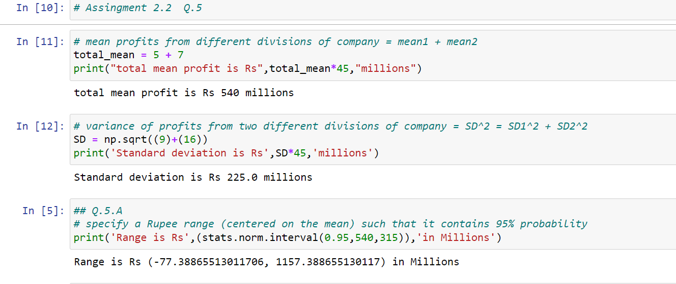

* **The Rupee range is -77.388 to 1157.388 in Millions.**

1. Specify the 5th percentile of profit (in Rupees) for the company

**ANS :**

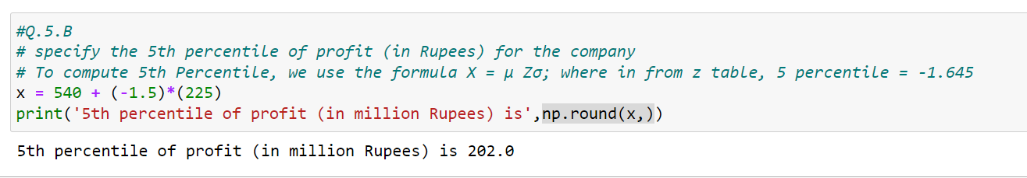

1. Which of the two divisions has a larger probability of making a loss in a given year?

**ANS :** 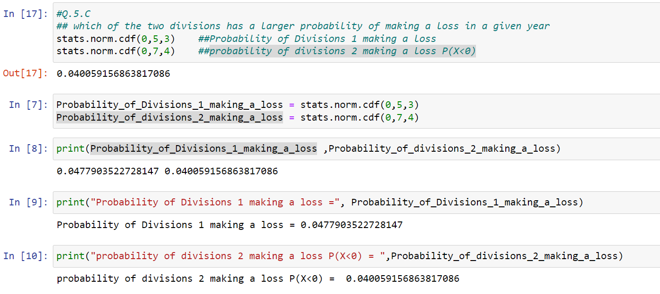

* **Probability of Divisions 1 making a loss = 0.0477903522728147**
* **Probability of divisions 2 making a loss P(X<0) = 0.04005915**